

MEDICAID ADMINISTRATIVE HEARINGS WITH THE MICHIGAN DEPARTMENT OF HEALTH AND HUMAN SERVICES (MDHHS)

Medicaid Appeals of adverse decisions made by Managed Care Health Plans, MI Health Link (Medicaid benefits only), Community Mental Health, Pre-paid Inpatient Health Plans, or MI Choice Waiver recipients.

You have a Right to Request a State Fair Hearing if:
- You are a Medicaid recipient and one of the above-mentioned agencies issued an adverse benefit decision:
  - Denying or limiting the authorization of a requested service.
  - Reducing, suspending, or terminating a previously authorized service.
  - Denying, in whole or in part, the payment for a service.
  - Failure to provide service in a timely manner.
  - Failure to resolve a grievance and provide notice to the affected parties within 90 days of receipt of the grievance.
  - Failure to resolve a local appeal and notice the affected parties within 30 days of receipt of the local appeal.
  - For residents in rural areas with only one managed care organization, the denial of his or her right to obtain services outside of the network.
  - Denial of an enrollee’s request to dispute a financial liability, including cost sharing, copayments, premiums, deductibles, coinsurance, and other
enrollee financial liabilities.
Local Appeal Requirement
- The local appeal is the first step of contesting an adverse benefit decision and must be completed before filing for a State Fair Hearing.
- You have 60 calendar days from the date of the written Notice of Adverse Benefit Determination to request a local appeal.
- If you are a Medicaid recipient and request your local appeal within ten days of the adverse benefit decision, you will continue to receive your benefits until a hearing decision is reached (subject to limited exceptions).
- You may request a local appeal orally or in writing.
  - Oral appeals must be confirmed in writing unless the provider requests expedited resolution.
- At your local appeal you should have an opportunity, in person or in writing, to present evidence and testimony and make legal and factual arguments.
- Notice of the decision on your local appeal must be provided within 30 calendar days from the date the appeal is received.
- All local appeal decisions must be in writing and include:
  - The results of the resolution and the date it was completed.
  - If the appeal is not wholly in favor of the consumer:
    - The right to a State Fair Hearing, and how to do so.
    - The right to request and receive continuing benefits while the hearing is pending, and how to make the request
    - Notice that the consumer may be liable for the cost of continuing benefits if the Administrative Law Judge (ALJ) upholds the adverse benefit decision.

How to Ask for a State Fair Hearing:
- You must file a local appeal and obtain an adverse decision before you can file for a State Medicaid Fair Hearing.
  - If you do not receive a decision on your local appeal request within 30 calendar days from the date the agency receives the appeal, and no extension has been granted, you may file a request for a fair hearing without obtaining a decision on your local appeal.
- A request for a State Fair Hearing must be in writing and it is recommended that you use the State approved form (MDHHS-5617-MAHS) for requesting a hearing. See Exhibit 1.
- You must state the reason you are requesting a State Fair Hearing and sign the hearing request.
- You may have someone represent you at the hearing. The person representing you does not need to be an attorney.
  - The person representing you must be at least 18 years old and you must give them permission to represent you.

Hearing Request Timelines
- You must request a State Fair Hearing within 120 calendar days from the date of the notice of resolution of the local appeal decision.
- If you are a Medicaid recipient and request your hearing within ten days of the local appeal decision, you will continue to receive your benefits until a hearing decision is reached (subject to limited exceptions).
  - It is important to note, if MDHHS’s decision is found to be correct, you may be responsible for paying back benefits you are determined to be not entitled to.

Before the Hearing
- You should get a notice in the mail with the date, time and location of the hearing. It will usually be held at the agency’s local office with the judge appearing by telephone.
- The notice will tell you about your rights at the hearing. You may represent yourself or have an attorney, friend or other advocate do it for you. You would need to notify the Michigan Administrative Hearings System (MAHS) if someone will be representing you.
- If you cannot attend, contact MAHS to postpone. The notice will also say if the hearing will be by phone or in person. Your hearing will most likely be by phone but that can be changed if you send a request, in writing, to MAHS asking for an in-person hearing.
- If you need transportation or childcare while you are at the hearing you need to contact your case manager, social worker, or support coordinator. If this is not helpful, you may contact MAHS and request an accommodation.
- If your disability prevents you from fully participating in the hearing process and you need accommodations, you should request accommodations along with your request for hearing. See Exhibit 1, Section 1.
  - You may also submit a disability accommodation request using the MAHS ADA Request Form. See Exhibit 2.
- If you have been denied an accommodation and think the denial was unlawful, you may file a complaint with the Michigan Department of Civil Rights. They may be contacted at:

Michigan Department of Civil Rights
110 W. Michigan Ave., Suite 800
Lansing, MI 48933
517.335.3165

- You should be provided with everything the agency that made the adverse benefit decision used to make its decision at least seven days before the hearing.
- You can provide any additional information you feel is relevant to the need for the services. When you submit additional information, be sure to reference the beneficiary’s name and provide the case number and date of hearing (if you have it) on the cover sheet. Additional information should be submitted via mail (no email) or fax to:

Michigan Administrative Hearing System
PO Box 30763
Lansing, MI 48909
Fax 517.763.0146

- You have the right to call witnesses at the hearing and should arrange for those witnesses to come to the hearing. If a witness refuses to appear, you may request, in writing, that the ALJ subpoena someone to testify at your hearing. Make sure you keep a copy of all documents you send to MAHS for your records.
- Be sure to submit your evidence to the ALJ before the hearing. Bring at least two copies of everything you want to be admitted into evidence. Once copy is for your reference and the other is for the agency’s representative.
- It is a good idea to arrange everything you want to submit with page numbers so documents are easy for you to find and refer to at the hearing. A cover sheet that lists the title of each item in order is also helpful. Remember that the ALJ will likely be appearing over the phone so you should consider this when making your argument and referring to documents that have been submitted to MAHS.

At the Hearing
- The hearing is tape-recorded. It begins with instructions from the ALJ. The judge will ask you to state and spell your name for the record and will swear in all witnesses who will be testifying.
- Each side can make an opening statement. The opening statement is not required, but it is a good idea to make a short statement letting the judge know what services are being affected.
  - Do not assume the judge has read all the information submitted before the hearing. Argue your case as if the ALJ knows nothing about you or the person you represent.
- All evidence that has been submitted will have to be entered into the record by the ALJ. You or your representative will have the opportunity to object to any information offered by the agency’s representative.
- Usually the agency making the adverse benefit decision will give their argument first and will call their witnesses during this argument. You or your representative will have the opportunity to ask questions of any witness the agency’s representative calls.
- You or your representative will then argue your side and can present any witnesses you have. The agency’s representative will have the right to ask questions of your witnesses.
- Make sure everything you think is important is said or entered into evidence at the hearing so it will go into the record. If it is not, the ALJ will not consider it in making his or her decision.
- Both sides have the option to make closing statements. If you chose to make a closing statement, try to summarize what has been presented as evidence and make a final request regarding what action you would like the ALJ to take in the case.

The Decision
- The ALJ does not usually give a decision at the end of the hearing. Typically, the ALJ will issue a written decision and mail it to you and your representative.
- If you disagree with the ALJ’s decision, you may appeal. The appeal rights will be on the last page of the Decision and Order.

Other Tips
- Try very hard to get to the hearing on time.
- Do not try to talk with the ALJ before the hearing. Do not interrupt when other people speak in the hearing.
- Answer all questions as honestly as you can, even if you say, “I don’t know.”
- Do not eat, drink or smoke during the hearing.

This information is a service of Disability Rights Michigan (DRM). It provides general information, based on the law at the time we wrote it, and is not legal advice. You do not have an attorney-client relationship with DRM. If you need legal advice, you should contact an attorney. If you would like more information about this topic or would like to receive this information in an alternative format call DRM at 800.288.5923 or visit our website, www.drmich.org.

Disability Rights Michigan (DRM) is mandated by federal and state law to protect the legal rights of individuals with disabilities in Michigan. DRM receives part of its funding from the Administration on Intellectual and Developmental Disabilities, the Center for Mental Health Services-Substance Abuse and Mental Health Services Administration (SAMHSA), the Rehabilitation Services Administration and the Social Security Administration.

Updated August 2020

EXHIBIT

1

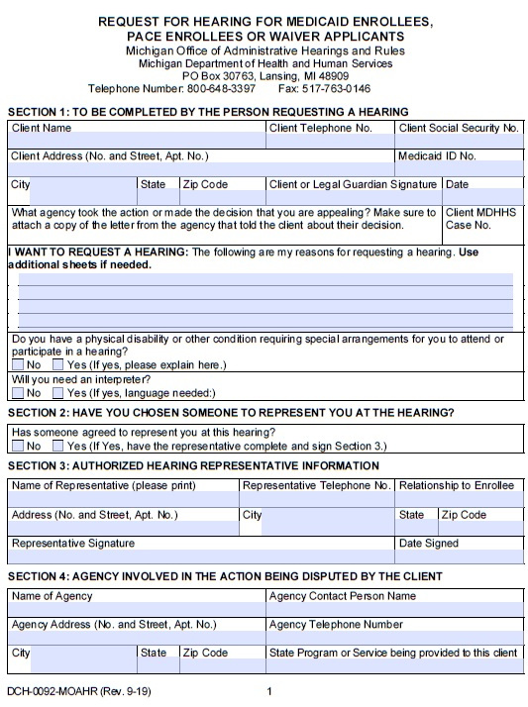
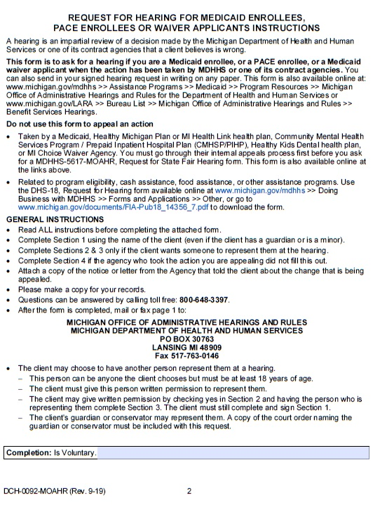
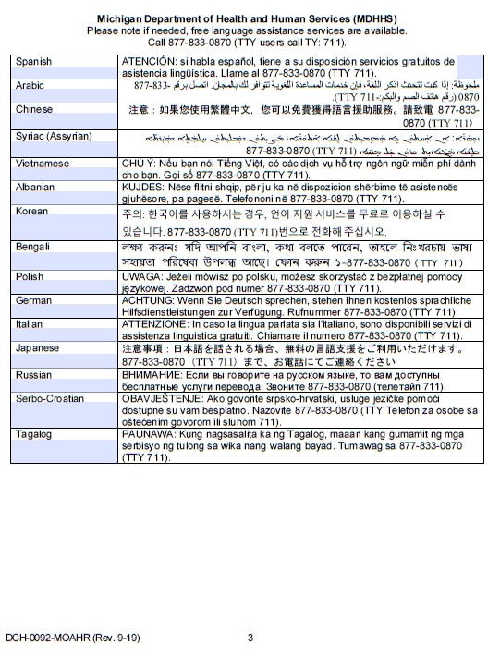
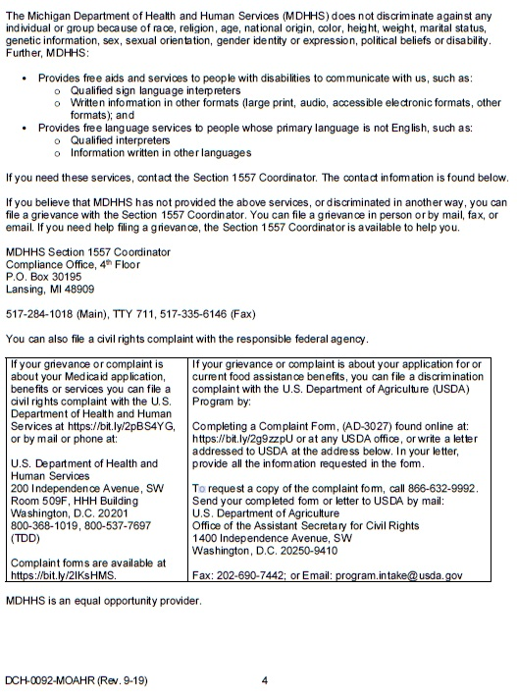

EXHIBIT

2

42 CFR 438.400(b)(1)-(7).
Timely manner is defined as 14 days from the authorization of the service under the State’s Contract with the managed care organizations.
42 CFR 438.402(c)(2)(ii).
42 CFR 431.230(a).
42 CFR 438.402(c)(3)(ii); 42 CFR 438.406(b)(3).
42 CFR 438.406(b)(4).
42 CFR 438.408(b)(2).
42 CFR 438.408(e)
42 CFR 438.408(f)(2).
42 CFR 431.230(a).
A subpoena requires a witness’s attendance at a hearing.

